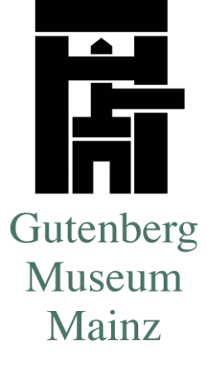
Permission to take photographs / film

We hereby allow the following visitor
Name/Company name _____________________________________________
Adress _________________________________________________________
Phone Number __________________________________________________
to  film  take photographs  audio recording.
on ____________ (Date of visit)

 inside the Gutenberg-Museum
 inside the printing workshop of the Gutenberg-Museum (Druckladen)

Reason for filming/taking photographs (please specify) ________________________________________________________________
________________________________________________________________
________________________________________________________________
Pictures / Films must not be taken with a flashlight or a comparably strong light and with a tripod only after special permission. It is not allowed to take pictures of or film visitors without their agreement. When children are the object of the photographer / film team, a signed permission of the parents must be produced. The user (photographer / film team) is responsible for obtaining the parents’ permission. Without a special agreement in writing, the photos / film material can be used only once for the agreed-upon reason and must not be copied. It is strictly forbidden to film/take photographs inside the vault.
This permission has to be presented on the premises of Gutenberg-Museum / Printing workshop upon demand.
______________________ ______________________
Director (stamp required) User

